**Question 5**

**Test case table:**

|  |  |  |  |  |
| --- | --- | --- | --- | --- |
| **Test Case Number** | Inputs | Exp Out | Basis Path Tested | Comments |
| x | y |
| 1 | -4.01 | 0.00 | 7-8-20 |  |
| 2 | -2.00 | 2.00 | 7-10-11-20 |  |
| 3 | 1.99 | 1.96 | 7-10-13-14-20 |  |
| 4 | 3.99 | 0.01 | 7-10-13-16-17-20 |  |
| 5 | 4.00 | 0.00 | 7-10-13-16-19-20 |  |
| 6 | -6.00 | 0.00 | - | Extreme range test |
| 7 | 8.00 | 0.00 | - | Extreme range test |
| 8 | -1.99 | 1.96 | - | Missing BVs |
| 9 | 2.00 | 2.00 | - | Missing BVs |
| 10 | -4.00 | 0.00 | - | Missing BVs |
| 11 | -3.00 | 1.00 | - | mid of linear region |
| 12 | 3.00 | 1.00 | - | mid of linear region |
| 13 | 0.00 | -2.00 | - | max of parabola region |
| 14 | -1.00 | -1.00 | - | mid point of min/max |

**Graph:**

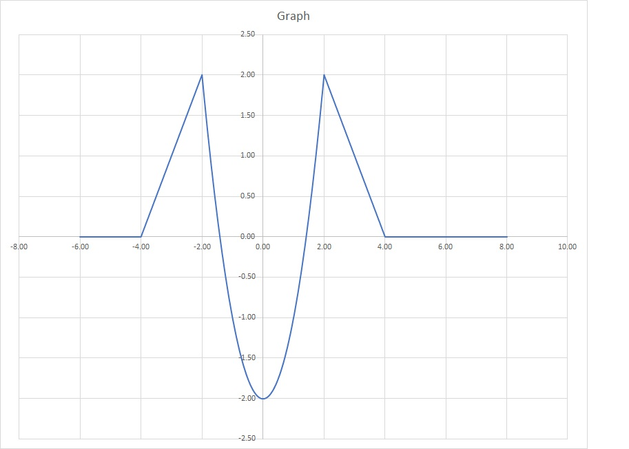

Code coverage achieved is: full boundary coverage, full statement coverage, full decision coverage and extreme range coverage.

The test cases support the description (logical expression).